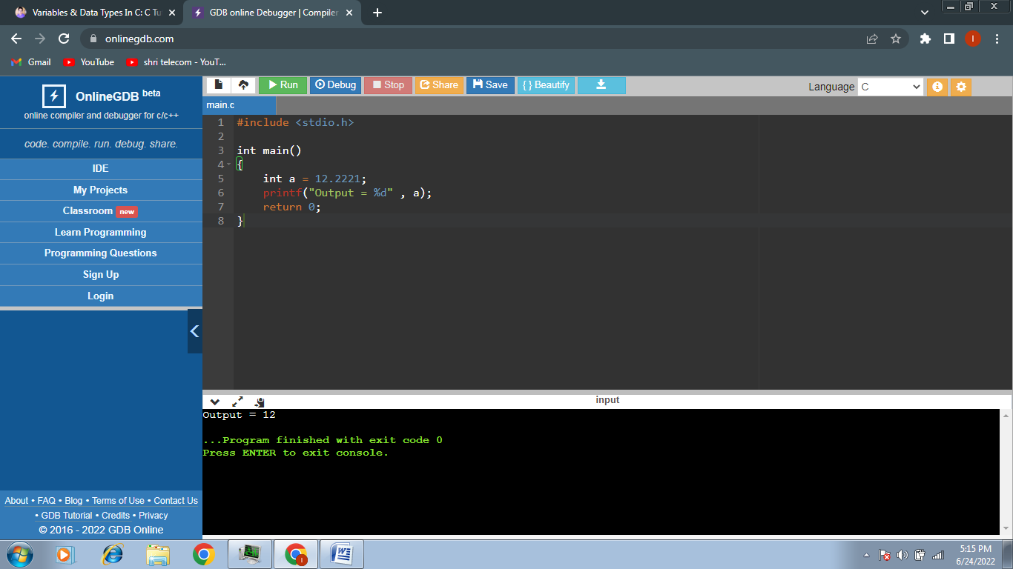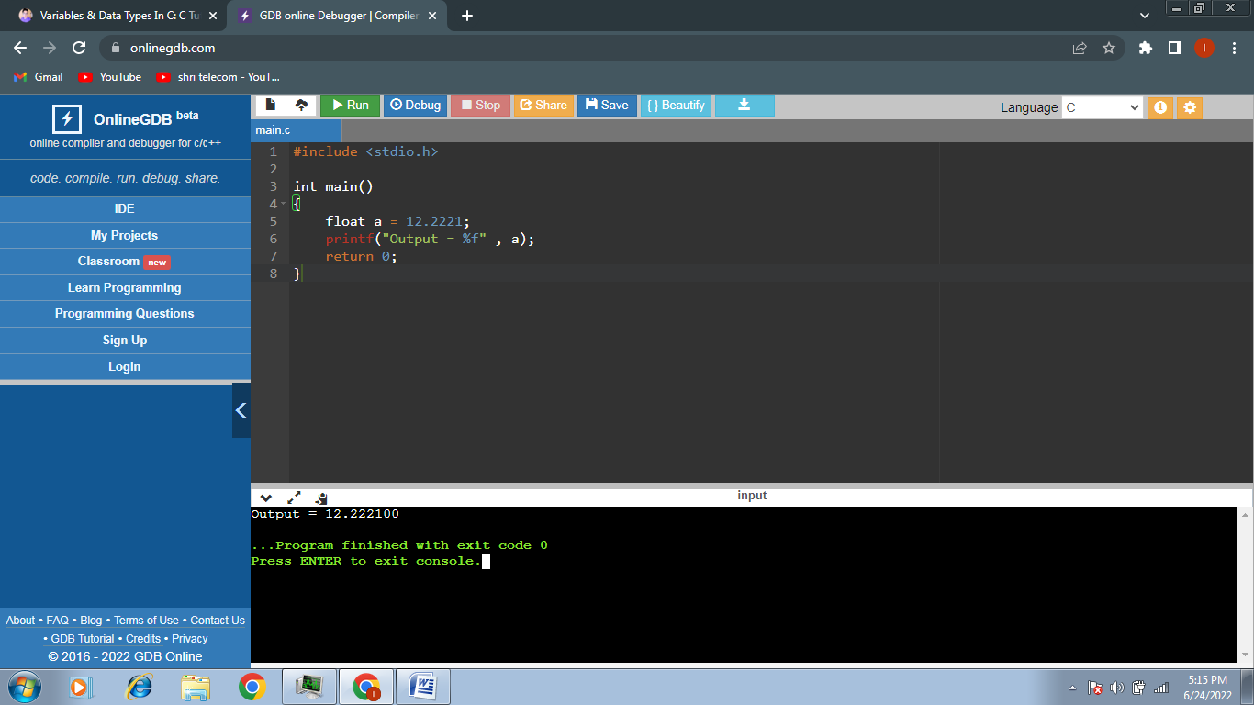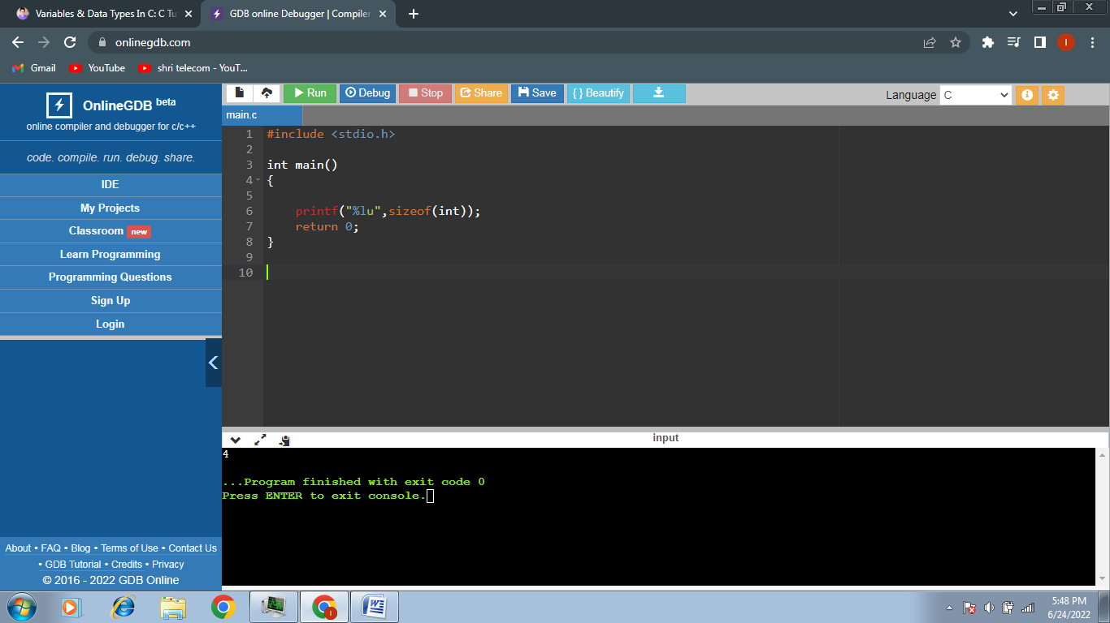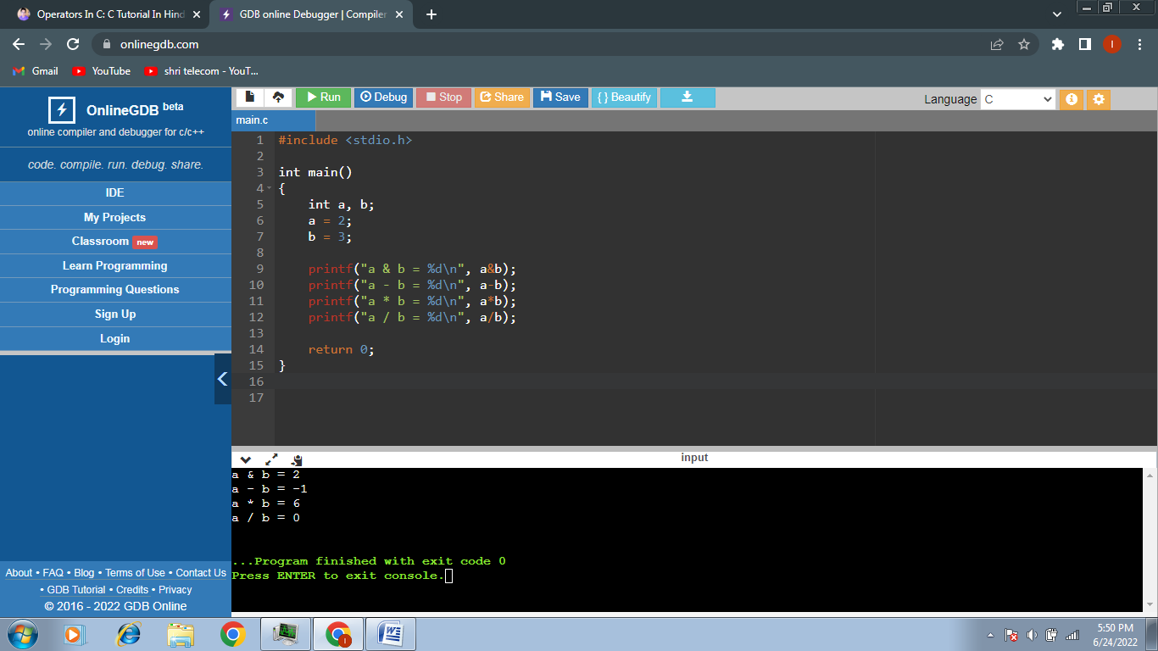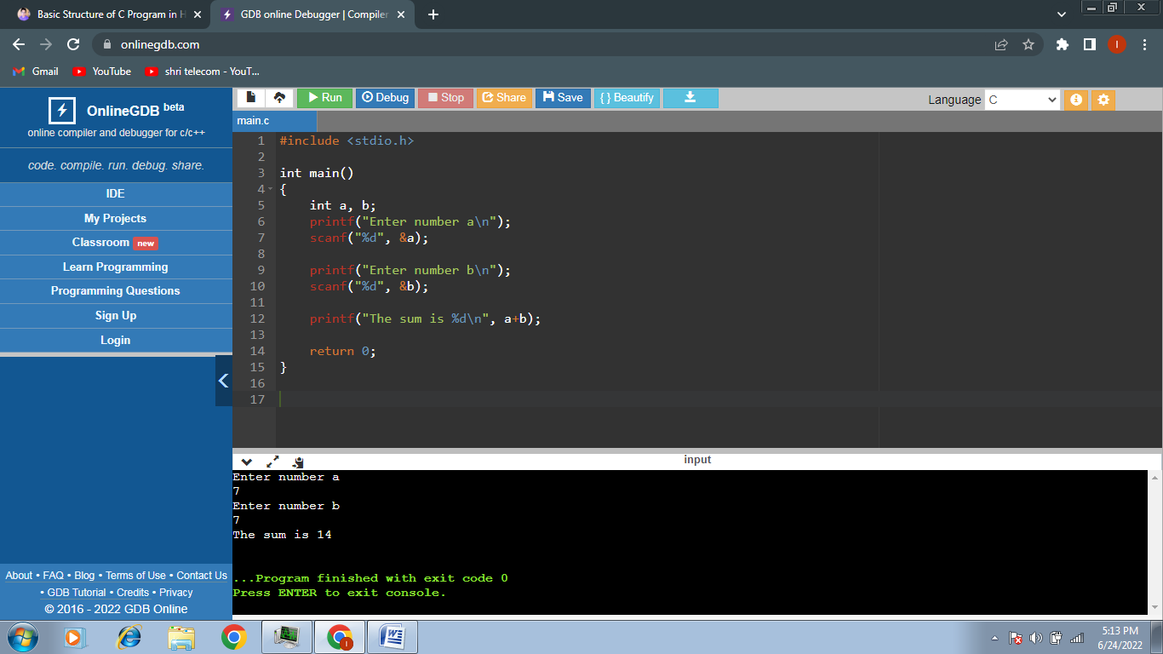

| **Format Specifier** | **Type** |
| --- | --- |
| **%c** | Used to print the character |
| **%d** | Used to print the signed integer |
| **%f** | Used to print the float values |
| **%i** | Used to print the unsigned integer |
| **%l** | Used to long integer |
| **%lf** | Used to print the double integer |
| **%lu** | Used to print the unsigned int or unsigned long integer |
| **%s** | Used to print the String |
| **%u** | Used to print the unsigned integer |

**Types of Escape Sequence in C**

| **Escape Sequence** | **Description** |
| --- | --- |
| **\t** | Inserts a tab |
| **\b** | Inserts a backspace |
| **\n** | Inserts a newline. |
| **\r** | Inserts a carriage return. |
| **\f** | Inserts a form feed. |
| **\’** | Inserts a single quote character. |
| **\”** | Inserts a double quote character. |
| **\\** | Inserts a backslash character. |

|  |  |
| --- | --- |
| **Conditions** | **Meaning** |
| a == b | a is equal to b |
| a  != b | a is not equal to b |
| a < b | a is less than b |
| a> b | a is greater than b |
| a <= b | a is less than or equal to b |
| a >= b | a is greater than or equal to b |

1)

#include <stdio.h>

int main( ) {

int num ;

printf ( "Enter a number less than 10 " );

scanf ( "%d", &num );

if ( num <= 10 ){

printf ( "Number is less than 10");}

else{

printf("Number is greater than 10");

}

return 0;

}

2)

main( ) {

int a;

printf ( "Enter either 0 or 1 " ) ;

scanf ( "%d", &a ) ;

if ( a == 1 ){

printf ( "Number 1 is entered!" ) ; }

else {

if ( a == 0 ){

printf ( "Number 0 is entered" ) ;}

else {

printf ( "Wrong Input" ) ; }

}

return 0;

}

3)

#include <stdio.h>

int main()

{

int age;

printf("Enter your age\n");

scanf("%d", &age);

printf("You have entered %d as your age\n", age);

if (age>=18) {

printf("You can vote!");

}

else if(age>=10)

{

printf("You are between 10 to 18 and you can vote for kids");

}

else if(age>=3)

{

printf("You are between 3 to 10 and you can vote for babies");

}

else{

printf("You cannot vote!");

}

return 0;

}

4)

#include <stdio.h>

int main() {

int i = 9;

switch (i) {

case 5:

printf("Value is 7");

break;

case 0:

printf("Value is 8");

break;

case 9:

printf("Value is 9");

break;

default:

printf("Value is not present");

break;

}

return 0;

}

5)

#include <stdio.h>

int main()

{

int age, marks;

printf("Enter your age\n");

scanf("%d", &age);

printf("Enter your marks\n");

scanf("%d", &marks);

switch (age)

{

case 3:

printf("The age is 3\n");

switch (marks)

{

case 45:

printf("Your marks are 45");

break;

default:

printf("your marks are not 45");

}

break;

case 13:

printf("The age is 13\n");

break;

case 23:

printf("The age is 23\n");

break;

default:

printf("Age is not 3, 13 or 23\n");

}

return 0;

}

6)

#include <stdio.h>

int main()

{

int n, sum = 0;

do

{

printf("Enter a number: ");

scanf("%i", &n);

sum += n;

}

while(n != 0);

printf("Sum is = %d",sum);

return 0;

}

7)

#include <stdio.h>

int main()

{

int num, index = 0;

printf("Enter a number\n");

scanf("%d", &num);

do

{

printf("%d\n", index + 1);

index = index + 1;

} while (index < num);

return 0;

}

8)

#include<stdio.h>

int main()

{

int i = 0;

while (i<54)

{

printf("%d\n", i);

i = i+1;

}

return 0;

}

9)

#include <stdio.h>

int main()

{

int num = 10;

int i;

for(i = 0; i < num; i++) {

printf("%d ",i);

}

return 0;

}

10)

#include<stdio.h>

int main()

{

int i,age;

for(i = 0 ; i < 5 ; i++) \

{

printf("Iteration time = %d\nEnter Your Age : ",i );

scanf("%d",&age);

if (age>10)

{

break;

11)

#include<stdio.h>

int main()

{

int a;

float b;

char c;

printf("Enter the value of a\n");

scanf("%d",&a);

printf("A is %d\n", a);

printf("Enter the value of b\n");

scanf("%f",&b );

printf("B is %d\n", (int) b);

printf("Type any character : \n");

scanf(" %c",&c );

printf("Character is %d",(int) c);

return 0;

}

}

} return 0;

}

12)

#include<stdio.h>

int main()

{

int table;

printf("\nEnter the number you want multiplication table of : ");

scanf("%d", &table);

int i;

for(i=0;i<11;i++)

{

printf("%d*%d=%d\n",table,i,table*i);

}

return 0;

}

13) #include<stdio.h>

int main()

{

printf("Lets learn about pointers\n");

int a=76;

int*ptra=&a;

printf("The address of pointer to a is %x\n",&ptra);

printf("The address of a is %p\n",&a);

printf("The value of a is %d\n",*ptra);

printf("The value of a is %d\n",a);

return 0;

}

14) #include<stdio.h>

int main()

{

printf("Pointer Basics\n");

int a =76;

int *ptra=&a

int *ptr2= NULL;

printf("The Address of pointer is %p\n", &ptra );

printf("The Address of a is %p\n," &a);

printf("The Address of a is %p\n",ptra );

printf("The Address of some garbage is %p\n",ptr2);

printf("The Value of a is %d\n", *ptra );

printf("The Value of a is %d\n", *a );

return 0;

}

15) /******************************************************************************

Online C Compiler.

Code, Compile, Run and Debug C program online.

Write your code in this editor and press "Run" button to compile and execute it.

*******************************************************************************/

#include <stdio.h>

int main()

{

char c;

int a,b;

printf("enter operator ");

scanf("%c",&c);

printf("enter first number ");

scanf("%d",&a);

printf("enter second number ");

scanf("%d",&b);

switch(c){

case'+':

printf("%d + %d = %d",a,b,a+b);

break;

case'-':

printf("%d - %d = %d",a,b,a-b);

break;

case'*':

printf("%d * %d = %d",a,b,a*b);

break;

case'/':

printf("%d / %d = %d",a,b,a/b);

break;

default:

printf("operator does not match");

break;

}

return 0;

}